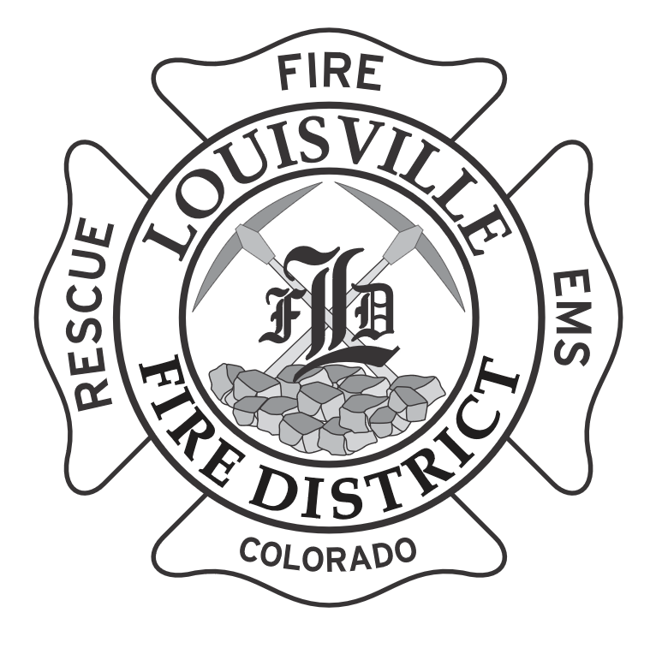 | LOUISVILLE FIRE PROTECTION DISTRICT  895 Via Appia Way, Louisville, CO 80027  303•666•6595 // www.louisvillefire.com
Date: October 5, 2026
Time: 6:30 pm
Physical Location: Fire Station #2, 895 Via Appia Way, Louisville, CO 80027
Virtual Attendance: See attached instructions to access the meeting.

Agenda is preliminary and subject to change by majority vote of the Board at the meeting. Individuals requiring special accommodation to attend and/or participate in the meeting should please advise the ADA Compliance Officer at 303-666-6595 of their specific need(s) as soon as possible prior to the meeting.

- Call to order & roll call
- Pledge of Allegiance
- Approval or amendments to the agenda
  - The Board may amend the agenda to remove or change any item listed on the agenda, add any new agenda item to the agenda, or reorder the agenda items. The Board may also table any agenda item for later discussion or reorder the agenda items at any time during the meeting if necessary to provide for the efficient conduct of the Board meeting.
- Public Comment- *see below for rules
- Consent Agenda
- Minutes from regular meeting 9/14/26
- Financial report (August 2026)

- Unfinished business
  - Budget Presentation
  - Strategic Plan update
  - Pension Contributions
- New Business
  - Amendment to CBA for Article 14, section 1- Acting pay
  - Discuss moving from Zoom to Teams for meetings
- Reports
  - Division Highlights Report
- Ratification of the Bills
- Board comments
- Future agenda items
- Adjournment
__________________________________________________________________________________________________________
*Rules for Public Comment:
- If you wish to speak please sign the “Public Comment” sign-up sheet. Speakers will be heard in the order listed.
- Try to limit your comments to 3 minutes. You may only speak once. You may not give part of your time to another speaker.
- Only one speaker will be acknowledged at a time. Please begin your comments by stating your name and the municipality or county you live in. .
- You must direct your comments to the Board as a whole, not individual Board members, the audience, or Staff. Discussions between speakers and audience members is not allowed.
- Public comments are not limited to agenda items but must be relevant to the District.
- The Board may choose not to respond to a question, or it may refer it to Staff for response, either at the meeting or at a future time.
- You are prohibited from engaging in personal attacks, using profanity, or engaging in other conduct that disrupts, disturbs, or otherwise impedes the orderly and efficient conduct of the meeting. Similarly prohibited are overly long, unduly repetitious, or irrelevant remarks that disrupt, disturb, or otherwise impede a meeting by preventing the Board from accomplishing its business in a reasonably efficient manner.

Louisville Fire District is inviting you to a scheduled Zoom meeting.

Topic: Louisville Fire District Board of Directors Meeting
Time: Oct 5, 2026 06:30 PM Mountain Time (US and Canada)

Join Zoom Meeting
https://us02web.zoom.us/j/85033368094?pwd=TI28bgNFQuv6yfpb20xk6faWbdxQD2.1

Meeting chat link
https://us02web.zoom.us/launch/jc/85033368094

Meeting ID: 850 3336 8094
Passcode: 364924

---

One tap mobile
+17193594580,,85033368094# US
+12532158782,,85033368094# US (Tacoma)

---

Join by SIP
• 85033368094@zoomcrc.com

Join instructions
https://us02web.zoom.us/meetings/85033368094/invitations?signature=S-YpZ1O7CWF_oMtUIRtxWZzhQFRHSNtwrKmyeVoHxZg

