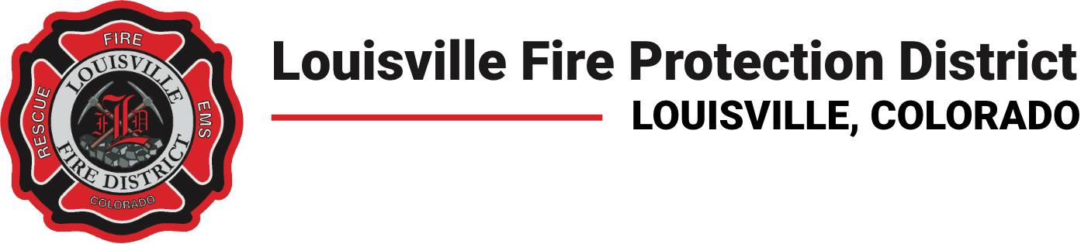

PUBLIC NOTICE

NOTICE OF MEETING OF THE
PENSION BOARD OF DIRECTORS FOR THE LOUISVILLE FIRE PROTECTION DISTRICT

PUBLIC NOTICE is hereby given that a meeting of the board of directors of the Louisville Fire Protection District shall be held at 6:30 p.m., on Monday, October 5, 2026, at the Louisville Fire Protection District
Station #2 895 Via Appia Way, Louisville, Colorado 80027.

Items to be discussed during this meeting include, but are not limited to review of the minutes, staff reports, and other matters that may come before the board.
Members of the public may attend the meeting in person or remotely. Remote access is available using the link or phone numbers provided below.

